**Question - 1:**

**How to import pandas and check the version?**

"import pandas" is importing statement used in python which is used to import the pandas module.

print(pandas.**version**) is used to print the version of the pandas module imported.

**Example:-**

*# importing pandas with alias name*

**import** **pandas** **as** **pd**

*# printing the version of pandas*

print(pd.__version__)

OUTPUT:-

1.1.4

**Question - 2**

**How to create a series from a numpy array?**

A series can be created from numpy array using 2 different way:

* using only numpy array value
* using only numpy array value along user index value

**Code**:-

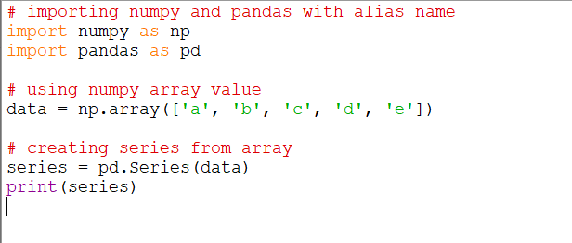

**OUTPUT:-**

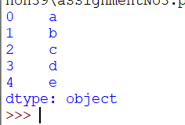

**Example:-**

*# importing numpy and pandas with alias name*

**import** **numpy** **as** **np**

**import** **pandas** **as** **pd**

*# using numpy array value*

data = np.array(['a', 'b', 'c', 'd', 'e'])

*# creating series from array with user index value*

series = pd.Series(data, index = [1, 2, 3, 4, 5])

print(series)

**OUTPUT:-**

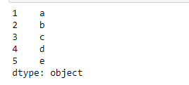

## Question - 3:

#### How to convert the index of a series into a column of a dataframe ?

#### Code:-

#### 

#### OUTPUT:-

#### 

## Question - 4:

#### Write the code to list all the datasets available in seaborn library.

#### Load the 'mpg' dataset

#### Code:-

*# importing seaborn*

**import** **seaborn** **as** **sns**

mpg=sns.load_dataset('mpg')

print(mpg)

#### OUTPUT:-

#### 

## Question - 5:

#### Which country origin cars are a part of this dataset?

#### Code:-

*# importing seaborn*

**import** **seaborn** **as** **sns**

*# importing pandas with alias name*

**import** **pandas** **as** **pd**

*# loading the dataset from seaborn*

mpg=sns.load_dataset('mpg')

*# creating a dataframe*

df = pd.DataFrame(mpg)

*# Displaying the country origin from where cars belong*

df.origin.unique()

#### OUTPUT:-

#### array(['usa', 'japan', 'europe'], dtype=object)

## Question - 6:

##### *Extract the part of the dataframe which contains cars belonging to 'usa'*

#### Code:-

*# importing seaborn*

**import** **seaborn** **as** **sns**

*# importing pandas with alias name*

**import** **pandas** **as** **pd**

*# loading the dataset from seaborn*

mpg=sns.load_dataset('mpg')

*# creating a dataframe*

df = pd.DataFrame(mpg)

*# Displaying the part from dataframe where cars belong to "usa"*

df[df['origin'].str.contains("usa")]

#### OUTPUT:-

#### 